2.4 and 3.1, 3.2 evidence

Below you can see how I verify whether my codes meets global standards. So that includes if a line is too long, if I added a space after # (When you make a comment in Python you need to add space) and so on. What I’m using for that is call [PEP8 online](http://pep8online.com/)

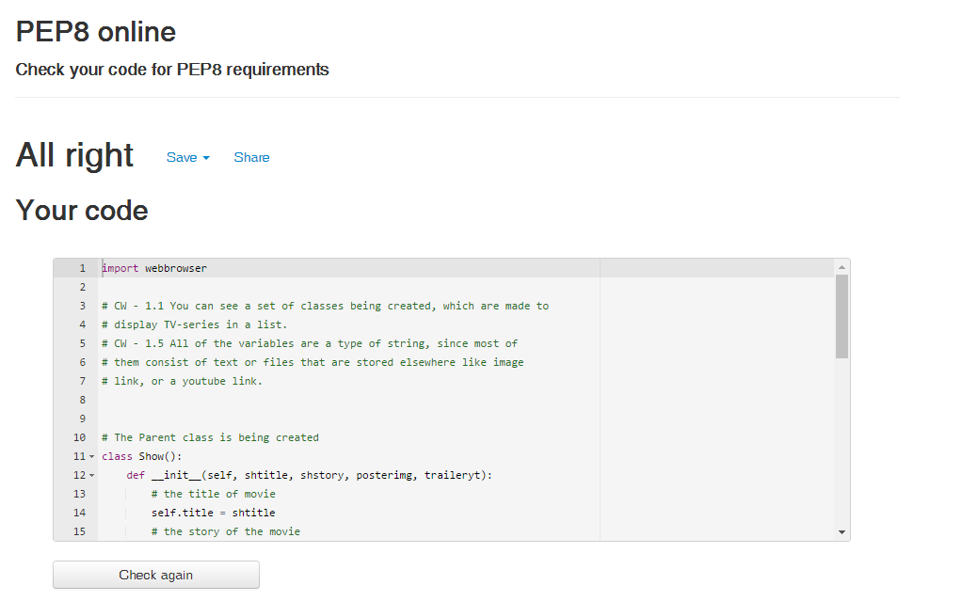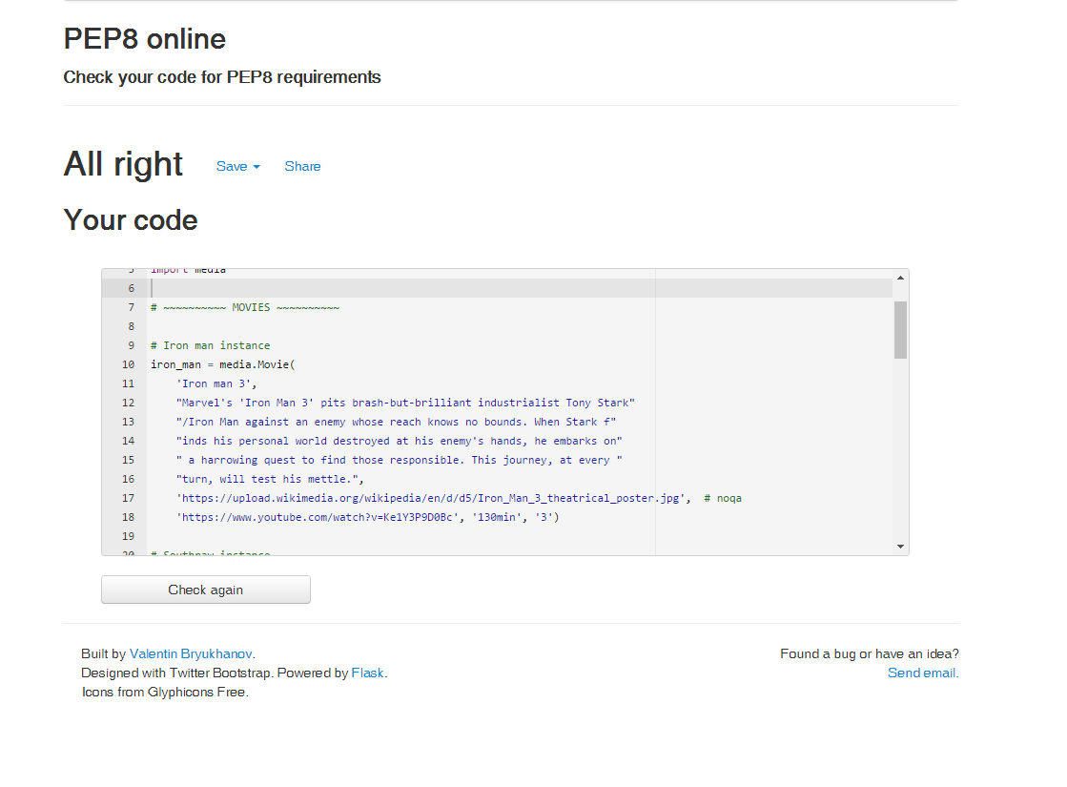

On the image below you can see the error that PEP8 however that is where I am adding my comment which will be converted to HTML. To avoid breaking the HTML I have left it as is. You can see one evidence that the line in which my code is too long and should’ve been moved to next line is HTML code.

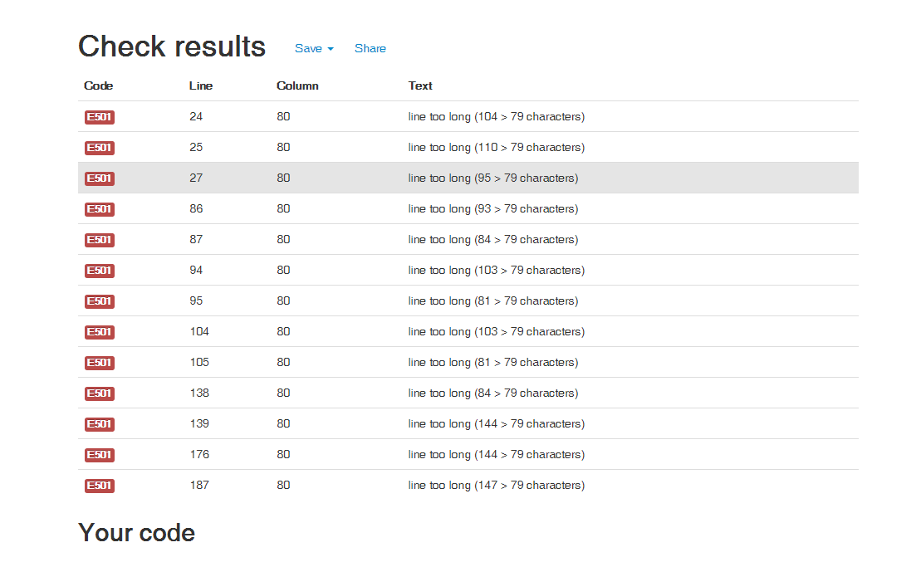

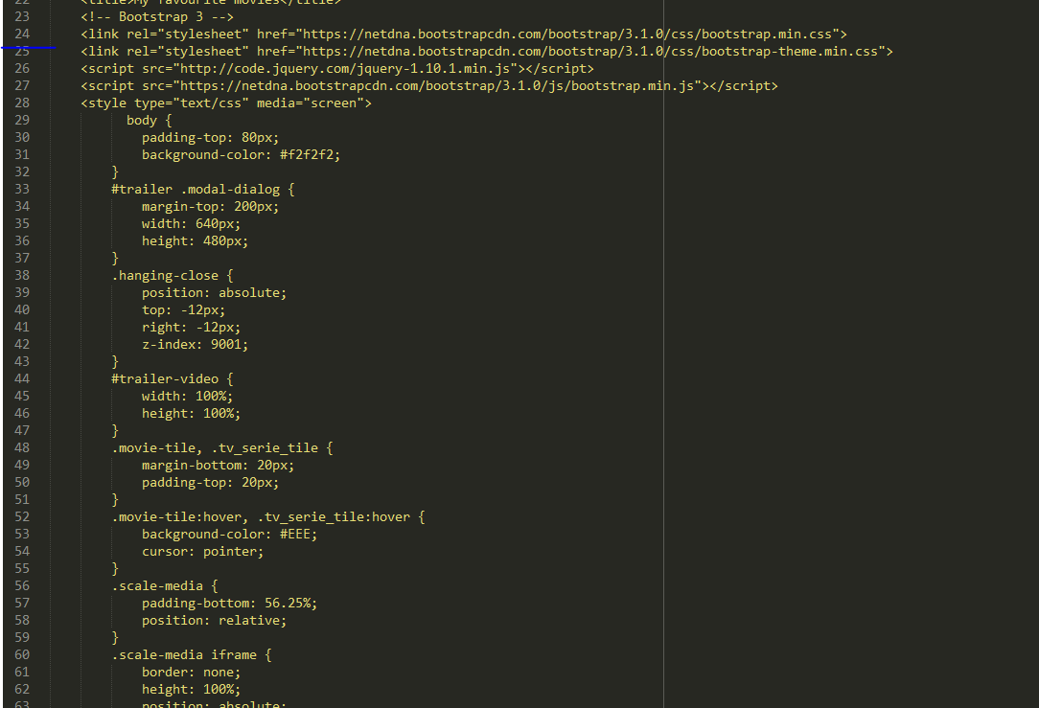

One of my debugging tools is the sublime console, which will tell me if there’s an error at running my code.

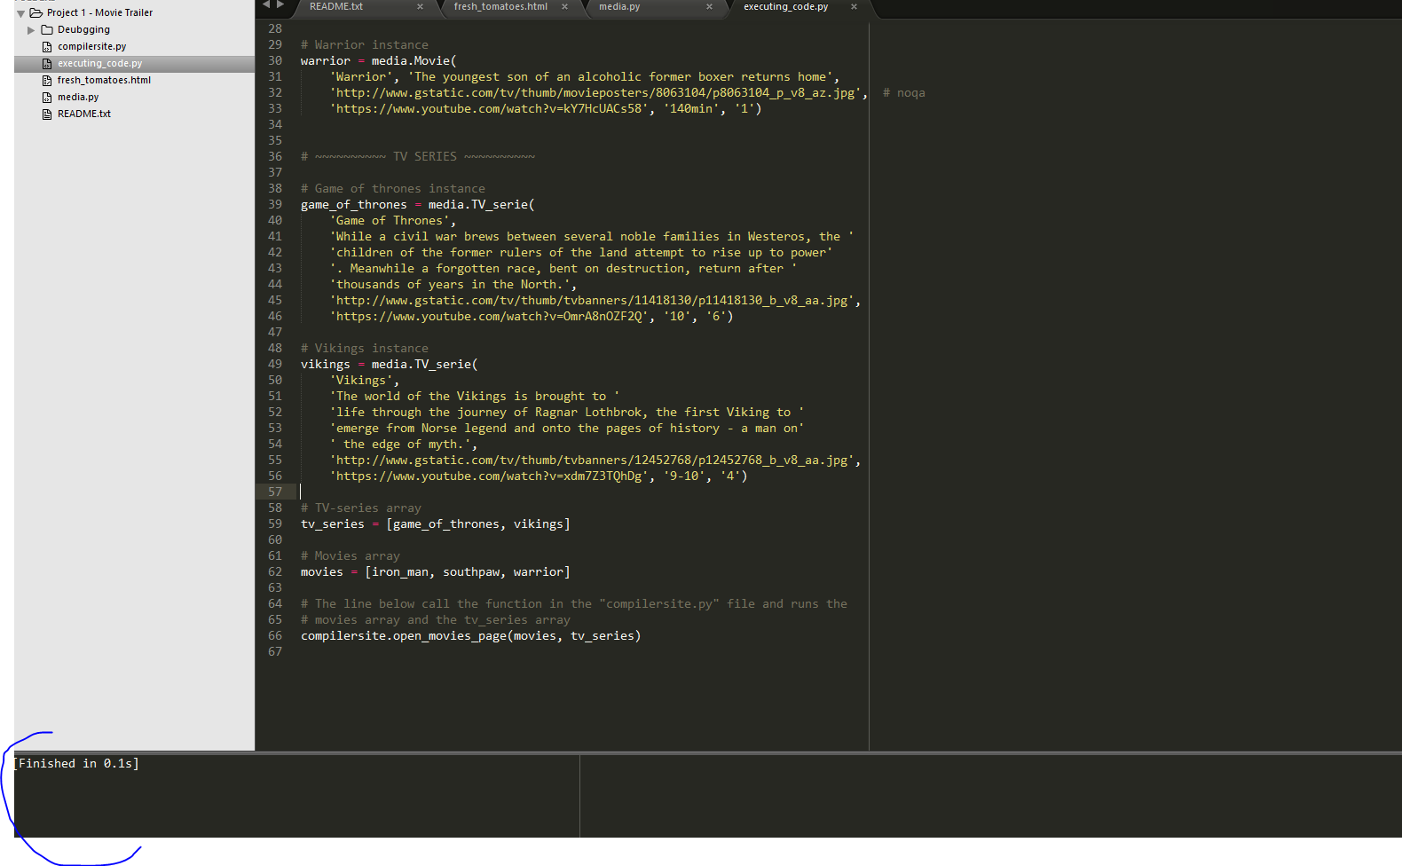

If I add some random stuff that would break it I get following notification:

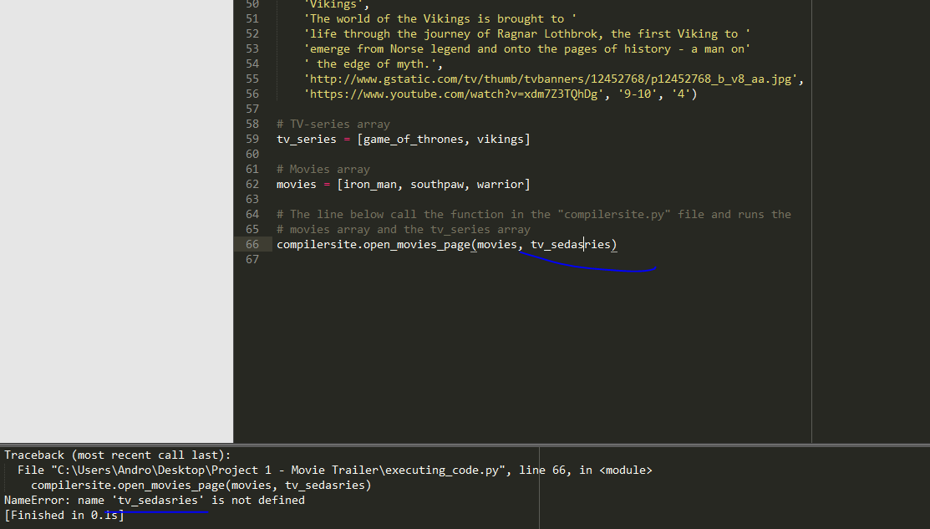

5.1 Final state of the site

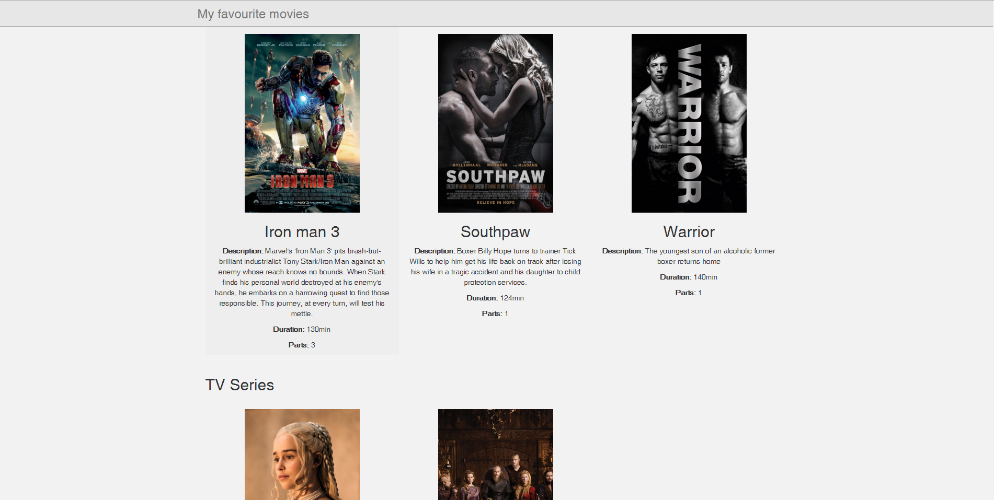

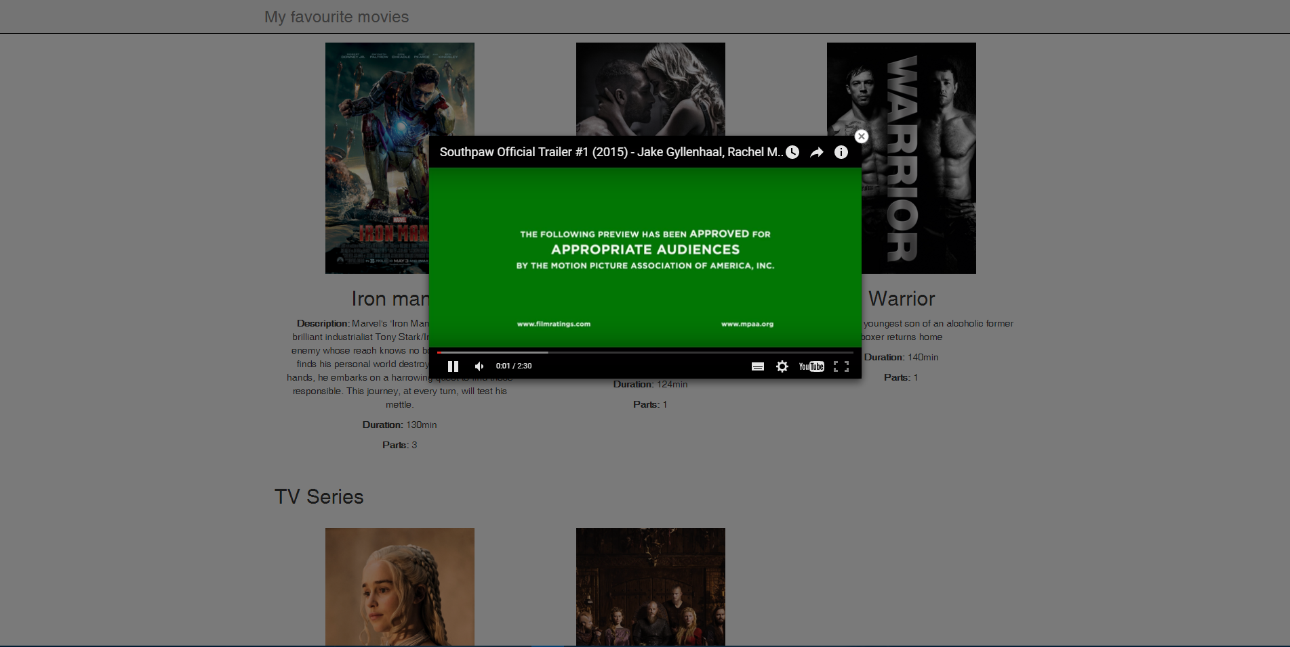

5.2 File called “README.txt”